- Purpose
  - The purpose of this document is to describe the procedure for assembling an Optima Propane Burnisher front bearing.
- Scope
  - This SOP applies to all equipment assembly team members. The process applies to the following machines:
E012800EQM0600BE1200 – 21” Optima XR
E012805EQM0600BE1200 – 21” Optima XR w/ Clutch
E012815EQM0600BE1200 – 21” Optima XR w/ Emissions & Clutch
E012830EQM0600BE1200 – 27” Optima XR
E012835EQM0600BE1200 – 27” Optima XR w/ Clutch
E012840EQM0600BE1200 – 27” Optima XR w/ Emissions
E012850EQM0600BE1200 – 27” Optima XR w/ Dust Control
E012860EQM0600BE1200 – 27” Optima XR w/ Clutch & Dust Control
E012865EQM0600BE1200 – 27” Optima XR w/ Emissions & Dust Control
E012875EQM0600BE1200 – 27” Optima XR w/ Emissions, Clutch, & Dust Control
- Responsibilities
  - The operations manager/supervisor is responsible for enforcing this SOP.
- Materials
  - The proper materials needed for this process are listed on the machine work order.
- Definitions

- Procedure
  - Start with a drive shaft hub (E80131). Press a bearing (E81771) into each side of the hub using the press and the steel block.

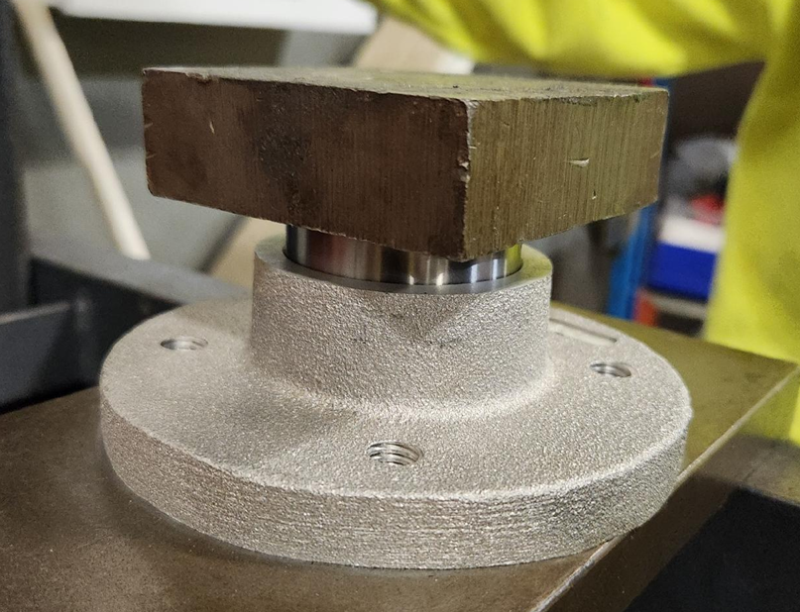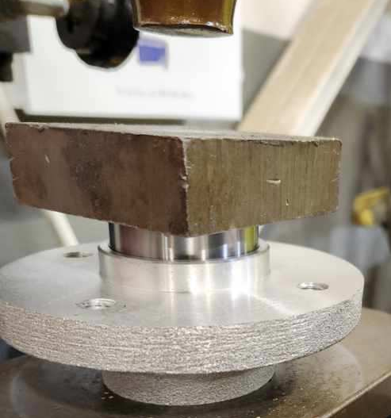
Bottom Side
Top Side
  - Install the shaft (E80132) into the hub/bearings in the orientation shown. The shoulder on the shaft should stop at the bearing. You can use the press to do this.

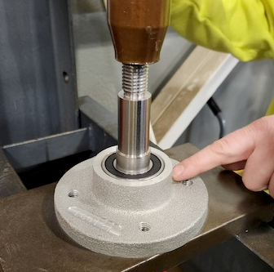

  - Install a snap ring (E12976) into the groove on the bottom of the shaft to hold it in place.
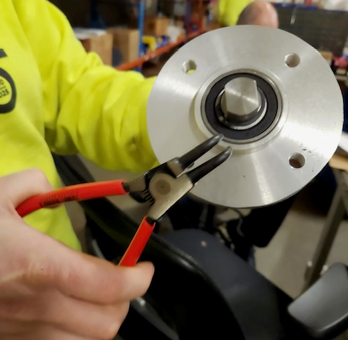

- References (optional section as needed)

- Training Guide

Functional Training Groups Requiring Training
Equipment Assembly Group

- SOP Change Control

Date of Change | Reason for Change
Rev 01 – 11/18/2025 | This is the first version of the S.O.P. hence there are no revisions to this document.

Approvals

Submitter/Author Approval:__________________________________ Date:______________________

Management Approval:______________________________________ Date:______________________

QAU Approval:_____________________________________________ Date:______________________

